睇樓紙／委托書

### IMG_256

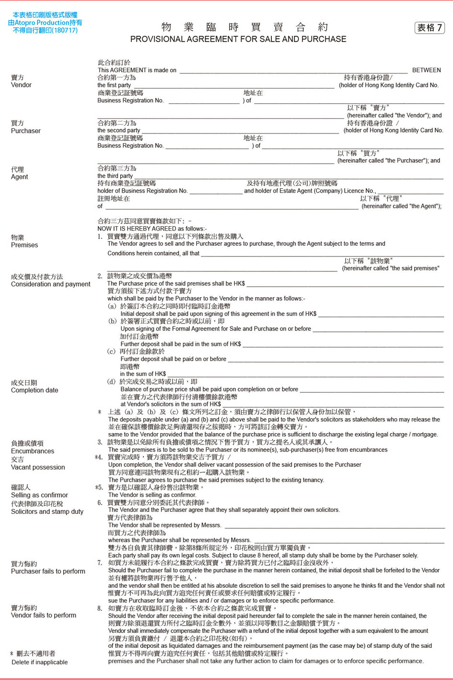

### IMG_258